Dear Parent/Guardian or Carer,
Is your child a Young Carer? Our aim is to ensure that all young carers receive the understanding and support they truly deserve.
Young Carers are under 18 years old and have a responsibility for looking after or helping someone else to look after a family member due to illness, disability, mental health difficulties, or substance dependency. Responsibilities can include assisting with daily routines, preparing meals, managing household chores, caring for siblings or providing emotional support.
Being a young carer can sometimes make school, home life, and friendships more challenging. We will be running a regular group filled with games and activities tailored for these pupils to enjoy and connect.
If you believe your child may be a young carer, please email Mrs Smith at homeschoolsupport@biltonjuniorschool.co.uk. We will then be in touch with you to discuss how we can support your child.
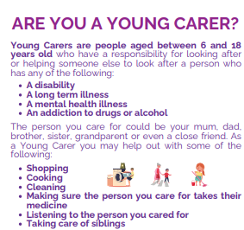
Kind regards
Alison Thompson
Assistant Head of School


