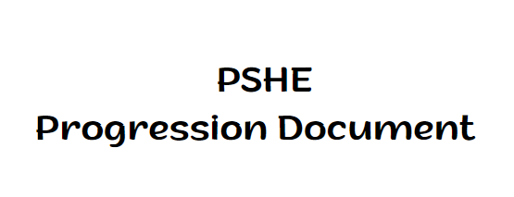

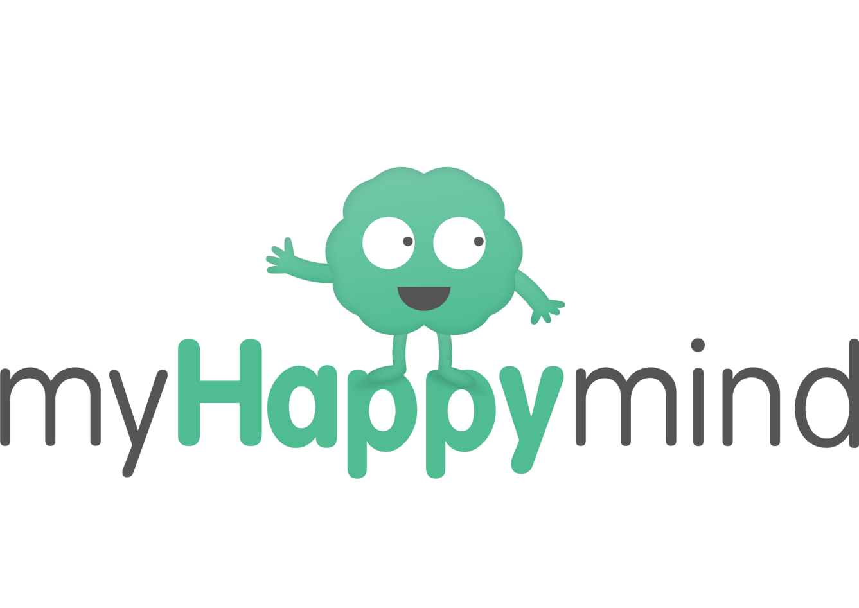
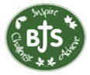

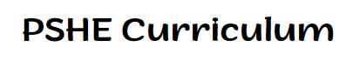

Curriculum Intent
It is our intent that children will leave our schools resilient, emotionally literate, aspirational, effective communicators who are happy and therefore ready for the next stage of their life through the behaviour, knowledge and skills they have learnt whilst in our care. If we can achieve this for our children then we believe we are giving them the best opportunity to achieve success in their life. Through an inclusive and stimulating environment we will develop every child and allow them to write their own story in life. This intent is defined as our REACH principles.
Resilient: Every child is resilient.
Emotionally Literate: Every child is aware of their feelings and those of others.
Aspirational: Every child aspires for more in their learning and in life.
Communicators: Every child is an effective communicator.
Happy: Every child has the right to be happy. Bilton Community Federation

Our vision is to empower children to make a positive impact on the world and to apply the following values in all they do: Care, Co-operation, Honesty, Forgiveness, Respect and Resilience.
Our Christian Values

Through our core Christian values, we want to ensure that our school is place that enables children to learn, feel safe, happy and feel valued, where they are able to flourish and experience God’s wonderful world in all its fullness. We focus on a different value every half term. These also form part of our PSHE curriculum through bible quotes.
Care: Ephesians 4:32 ‘Be kind and compassionate to one another, forgiving each other, just as in Christ God has forgiven you.’
Respect: Matthew 7:12 ‘Do to others how you would them to do to you.’
Honesty: Ephesians 4.25 ‘So stop telling lies, let us tell our neighbours the truth for we are all part of the same body.’
Resilience: Galatians 6:9 So let’s not get tired of doing what is good. At just the right time we will reap a harvest of blessing if we don’t give up.’
Co-operation: Proverbs 17:17 ‘A friend is always loyal and a brother is born to help in time of need.’
Forgiveness: Colossians 3:13 ‘Make allowance for each other’s faults, and forgive anyone who offends you. Remember, the Lord forgave you so you must forgive others.’

Mental health in schools’ team
At Bilton C of E Junior School, we are committed to supporting the emotional health and wellbeing of our pupils, staff and families and believe in a whole school approach to achieve this. We understand that taking proactive steps to get additional emotional support is invaluable. We have strong links with the local Mental Health in Schools Team (MHST) and bespoke workshops provided by the team form part of the PSHE programme for children at BJS.

Protective Behaviours
At Bilton C of E Junior School we follow a whole school programme that aims to equip children with the tools to keep them safe. Protective Behaviours is a practical approach to personal safety, self-esteem, resilience and confidence building. This is introduced in every class at the beginning of the school year and regularly revisited throughout the year. Protective Behaviours is based on two themes, which are used to teach and reinforce the basic concepts on which the process is based. We all have the right to feel safe all the time We carefully look at the connection between rights and responsibilities. We explore feeling safe and the recognition of Early Warning Signs. We can talk with someone about anything even if feels awful or small
This theme focuses on the ideas and effects of ‘talking’ and what might happen if we don’t. We encourage everyone to develop their own personal networks of support, those people they could turn to if in need.

My Happy Mind
myHappymind is an award winning, NHS backed whole school and nursery curriculum. It teaches children preventative habits that support positive mental health, resilience and self-esteem. Taught to every child in a school from Year 3 through to Year 6, myHappymind is delivered via an innovative technology platform making learning easy and fun. All of the concepts we teach are based in science and research and grounded in Neuroscience and positive psychology.

What is taught in MyHappyMind
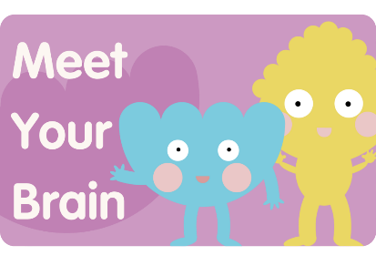
Children learn how their brain works, how emotions happen, and simple ways to calm, focus and manage big feelings. Celebrate Children learn to recognise their character strengths, celebrate what makes them unique, and build confidence and self-esteem. Appreciate Children learn about gratitude and how noticing positive things can support wellbeing, resilience and a happier mindset. Relate Children learn why positive relationships matter and how to build friendships through kindness, empathy, respect and understanding others. Engage Children learn how to set meaningful goals, stay motivated and keep going when things feel challenging.

MyHappyMind Plus
myHappymind Plus is our school's PSHE Programme. The programme is compliant with the Statutory Guidance for Relationships, Sex, Health Education (RSHE) and it also teaches non-statutory PSHE objectives, providing a well-rounded curriculum. myHappymind Plus is made up of 3 core content pillars which run alongside the myHappymind core programme: myHappymind – Core programme myHappybody - Section 1 - Section 1: Relationships (Sex) and Health Education (RSHE) myHappyrelationships - Section 1: Relationships (Sex) and Health Education (RSHE) myHappyworld - Section 2: Economic Wellbeing and Careers Education Lessons have been reviewed and developed to support schools in delivering age-appropriate, progressive and statutory Relationships, Sex and Health Education.

Year 3
Meet your Brain
Places
Celebrate
Appreciate
Relate
Engage
Friendships and showing respect
Families and trusted relationships
Changing and growing
Protecting our communities
Year 4
Meet your Brain
Places
Celebrate
Appreciate
Relate
Engage
First Aid
Online Safety
Bullying
Safe Choices
Changing and growing
Economic Wellbeing
Year 5
Meet your Brain
Places
Celebrate
Appreciate
Relate
Engage
Healthy Choices
Economic Wellbeing and careers
Safe relationships
Growing and changing
Year 6
Meet your Brain
Places
Celebrate
Appreciate
Relate
Engage
Protecting our communities
Growing and changing
Online Safety
Safe relationships
Be your best

